Booking Export: change log thru April 17, 2025

- Added the custom fields that a client can show in booking flow to the export. More info on these fields can be found here: https://supportdesk.odysol.com/portal/en/kb/articles/how-to-set-additicustom-fields

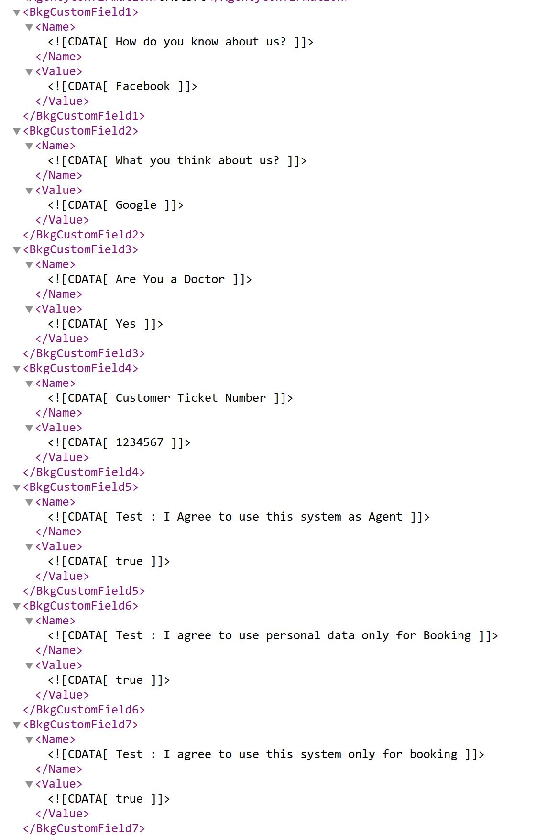
- To display a section for Associated bookings in export and include fields - TransactionId, AgencyConf#, Booking# and Cabin#. —> this is useful for associate bookings and multi-cabin bookings.

Note: The Associate booking and multi-cabin booking flow features are add-on options that incur a cost, however if you have subscribed to this feature and also booking export, you will see the below options.

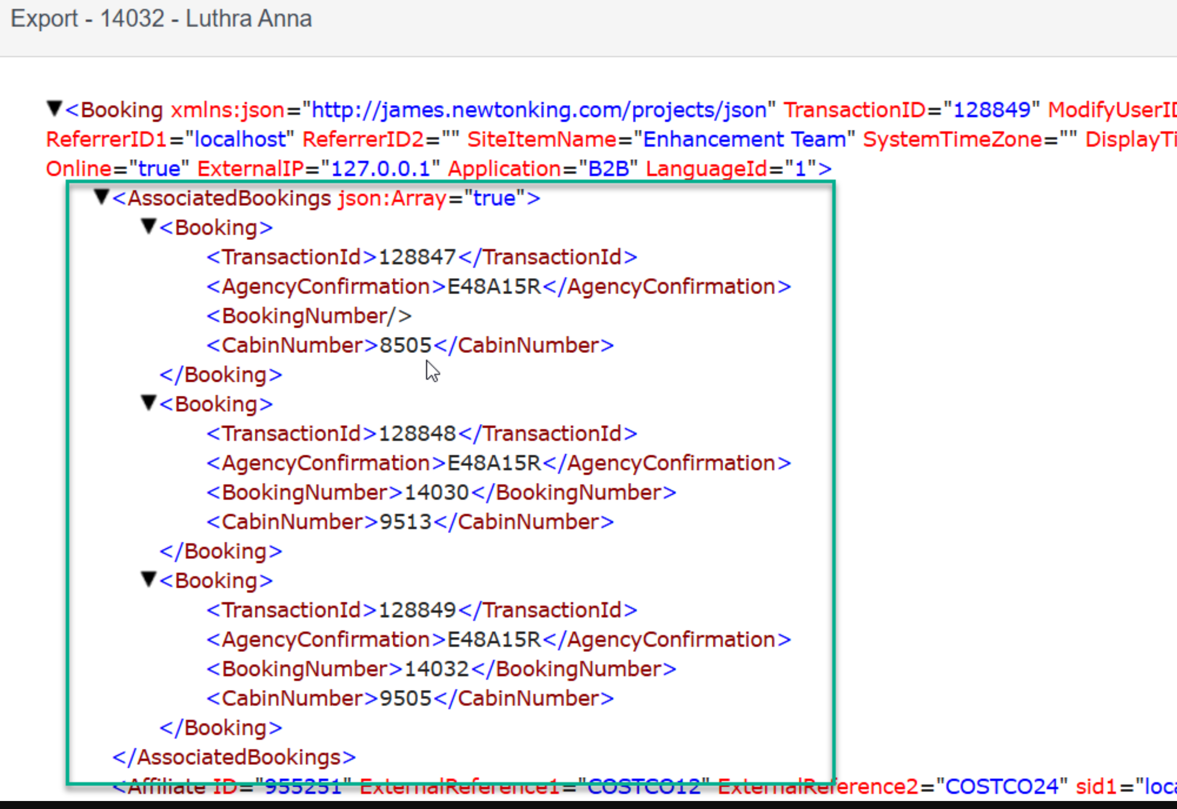

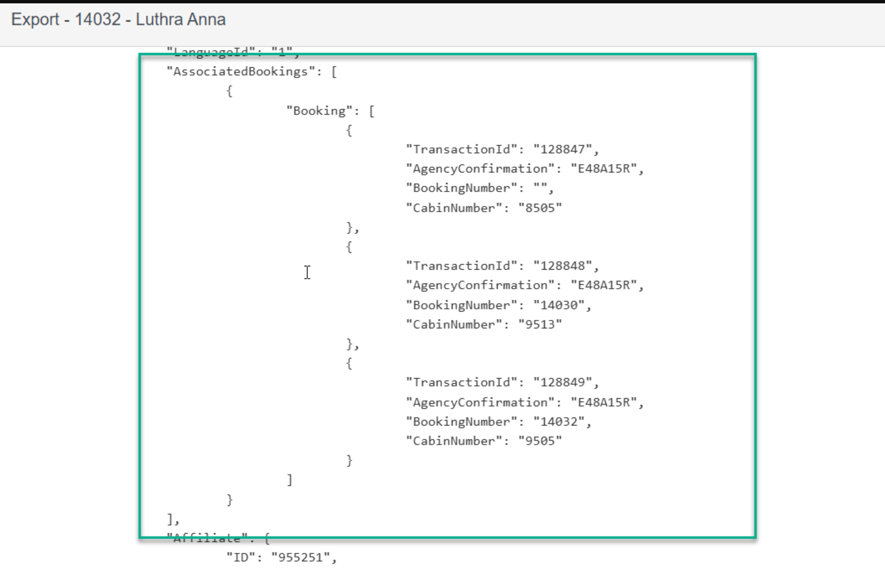

- Added Pay Later Provider API flag to export booking (Uplift/Flexpay)
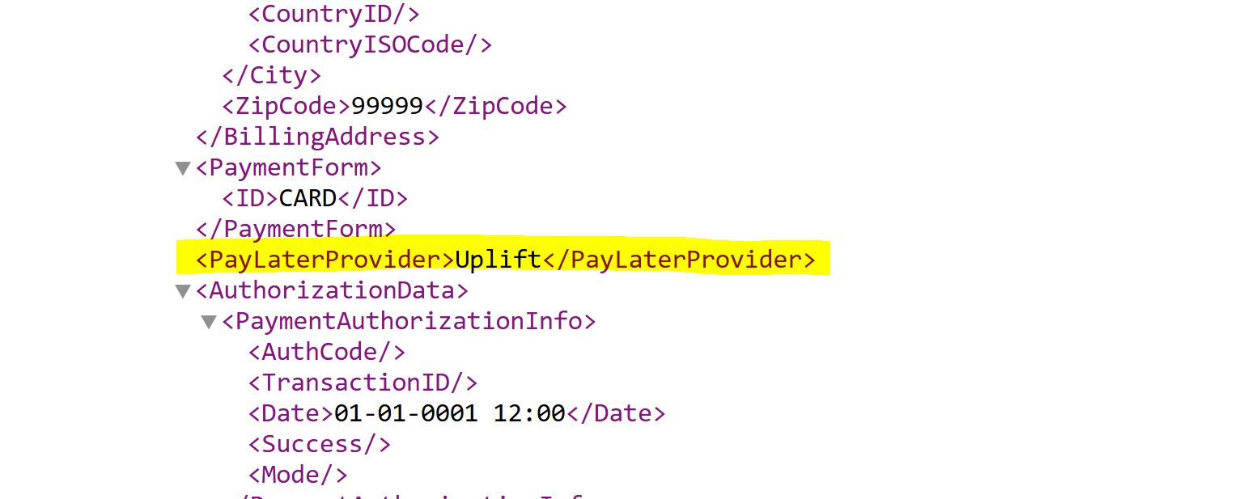

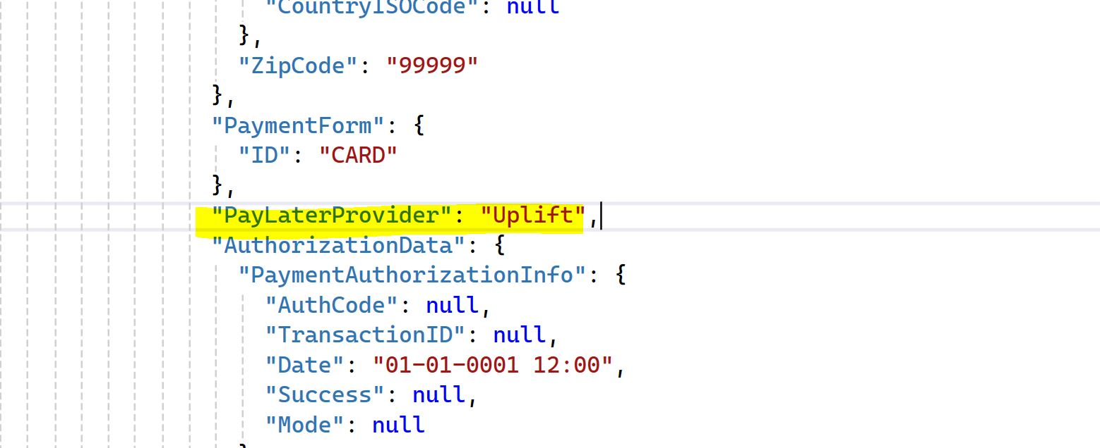

- Added device details to the booking export:
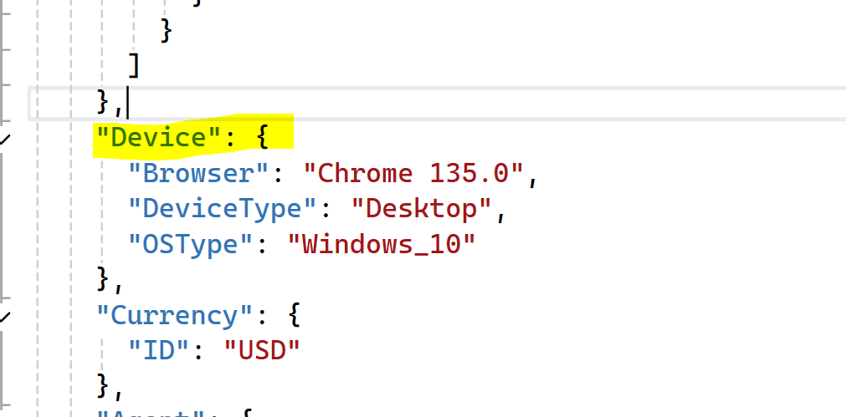
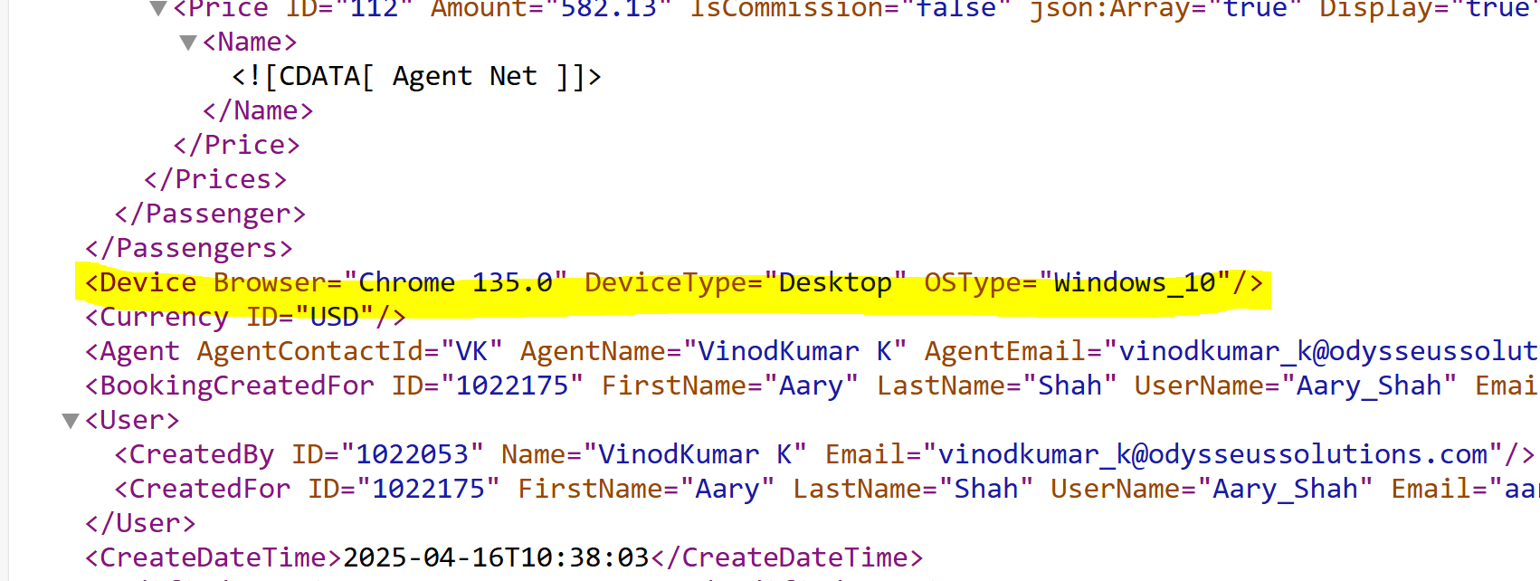
The following are the device types you can get:
- Desktop
- mobile
- ios
- ipad
- iphone
- ipod
- android
- symbian
- windows phone

- Added CC Bin # when available to the export. BIN number is the first 6 digits of the CC and only available till the CC is destroyed. Once the CC is destroyed this BIN number may not be available.

